**BINARY CODE TO GRAY CODE CONVERSION**

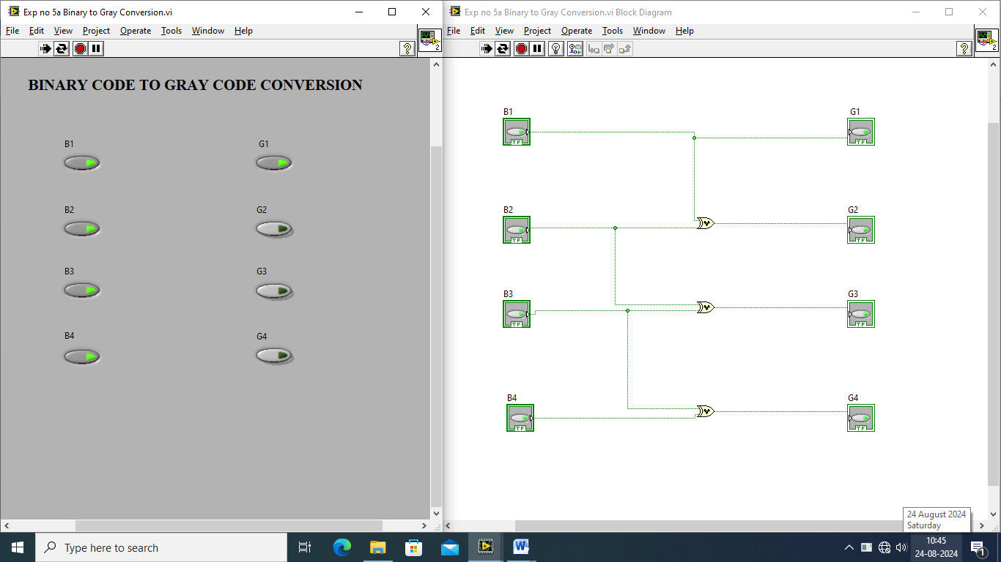

**GRAY CODE TO BINARY CODE CONVERSION**

